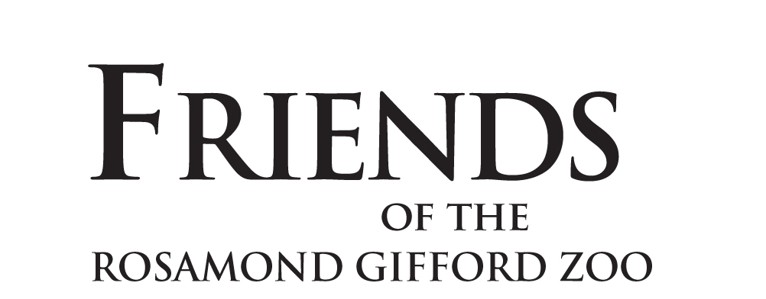

Non-binding Letter of Intent
CONFIDENTIAL

I/we wish to strengthen and sustain the important mission of Friends of the Rosamond Gifford Zoo, not only today but also into the future. Therefore, I/we wish to inform you that I/we have included Friends of the Rosamond Gifford Zoo in my/our estate plan.

Signature: __________________________________ Date: _______________

Signature: __________________________________ Date: _______________

Name(s) _________________________________________________________

Address __________________________________________________________

City ________________________ State _________________ Zip __________

Phone _________________________ Email ____________________________

Your gift entitles you to be included in The Elephant Society. Please tell us if we may publish your name there: Yes ____ No ____

Please list your name as it should appear for recognition purposes: _________________________________________________________________

Thank you for your generosity in making this gift and for informing us of your estate plans.

To help us recognize your gift appropriately, we request the following optional information:

This gift has been arranged through a
___ Bequest
___ IRA/Retirement plan beneficiary designation
___ Charitable Gift Annuity
___ Charitable Remainder Trust
___ Other gift (please describe) __________________________________________________________________________________________________________________________________

The estimated value of this gift is $__________________________

This Letter of Intent is not a legal obligation and may be changed at the donor’s discretion. Friends of the Rosamond Gifford Zoo handles all personal information confidentially and does not share any information outside Friends of the Rosamond Gifford Zoo.

Please retain a copy of this letter of intent for your records. Should you have any questions, please contact our development office at (315) 435-8511 ext. 132 or ext. 108.
Thank you for making a difference in Central New York by supporting
Friends of the Rosamond Gifford Zoo!

